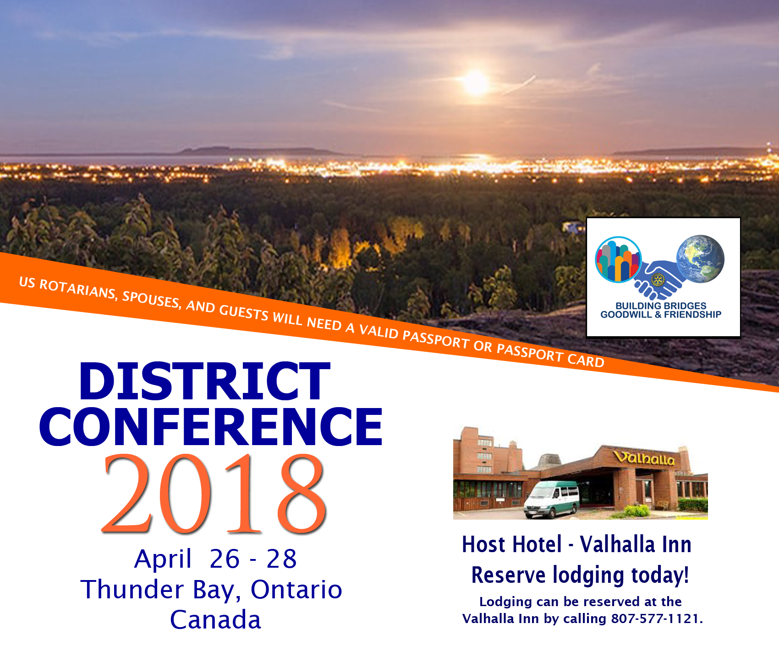

2018 DISTRICT CONFERENCE TRANSPORTATION  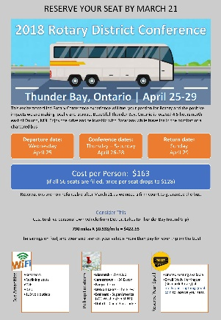  We have a transportation  option for conference attendees! This transportation option includes a  FUN experience  at a GREAT PRICE! | MORE INFORMATION_ _  Online Registration  Printable Registration Form  Transportation  Speakers  Hotels  Valhalla Inn  Visiting Thunder Bay  Entering Canada  U.S. Passports - Apply or Renew Online

REGISTER TODAY!
WWW.ROTARY5580.ORG

